England Labour Relations Dataset c.1800 Methodological Paper

Arianne Zajac
International Institute of Social History
Global Collaboratory on the History of Labour Relations, 1500-2000

Supervisors:
Karin Hofmeester, IISH
Vigyan Ratnoo, Utrecht University

Contents

List of tables
Maps
Introduction 5
Explanation of sources 5
Sample Regions 6
Demographic 7
(Non-)working populations 9
Estimation of male labour relations 10
Estimation of female labour relations 12
Summary of total labour relations 15
Notes 17
Bibliography 17
List of Tables
England total population 8
Sheffield population 8
North Riding of Yorkshire population 9
Male summary of labour relations 15
Female summary of labour relations 16
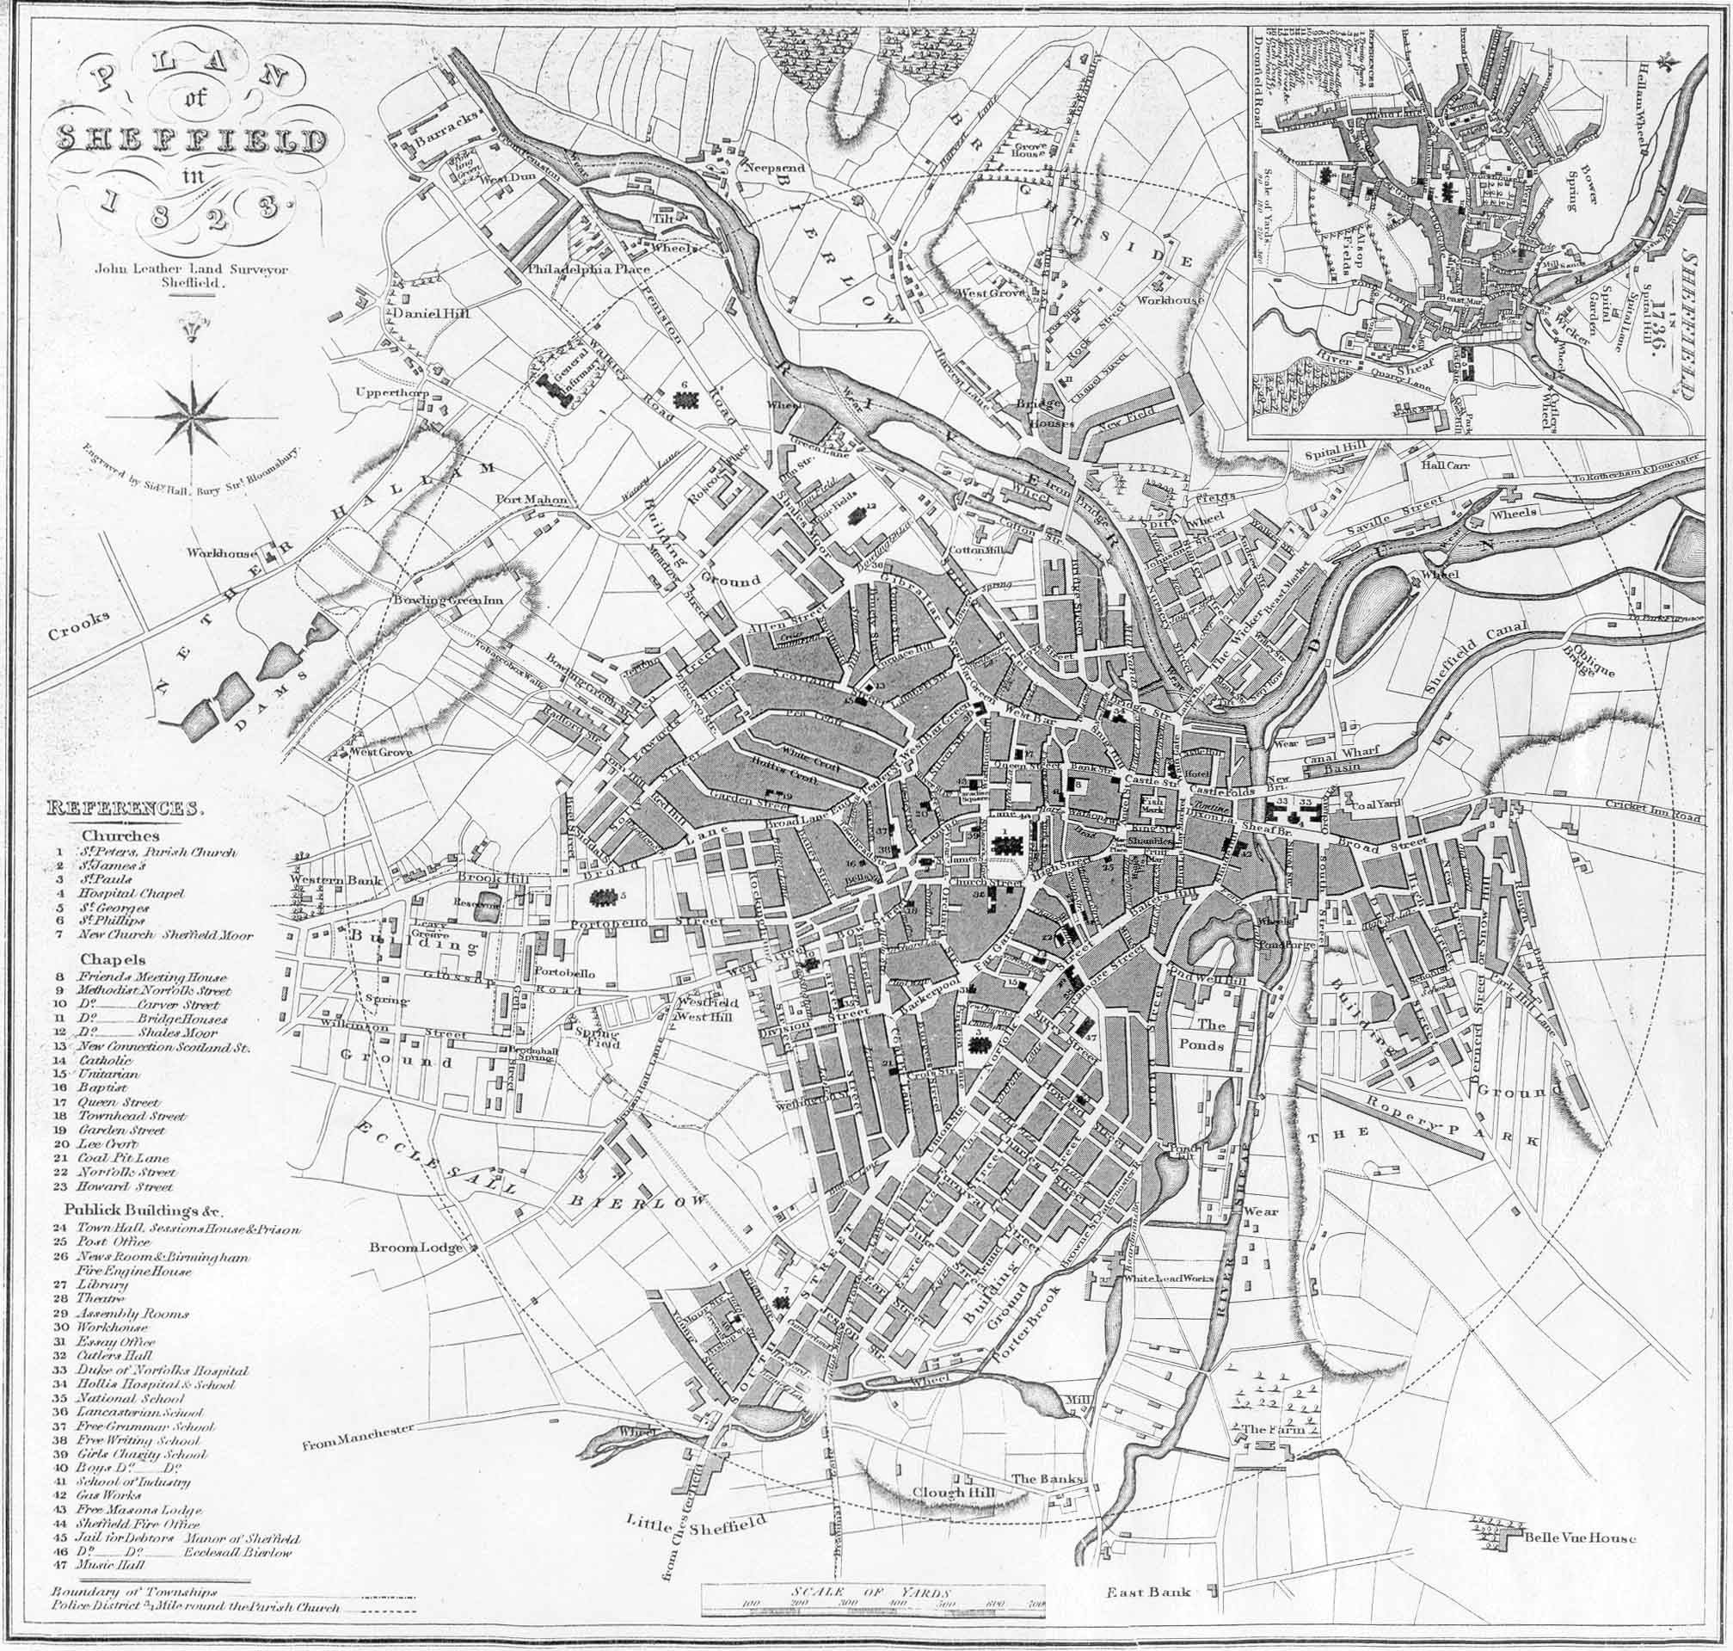

John Leather’s 1823 Map of Sheffield.

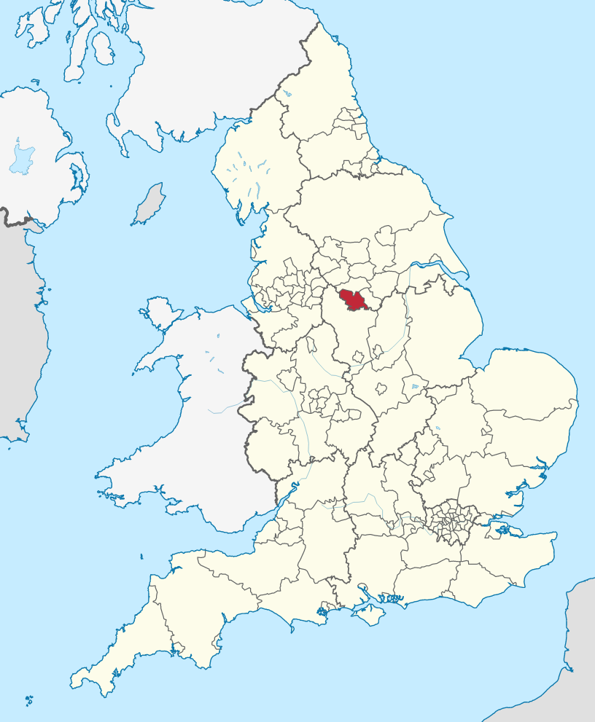
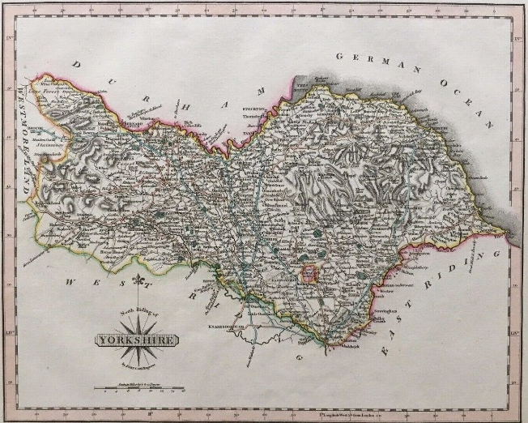
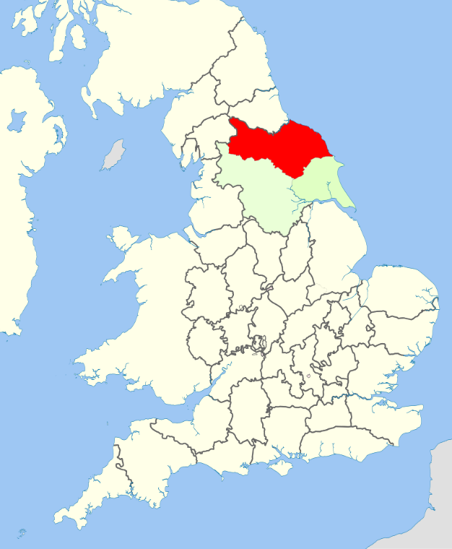
The city of Sheffield shown in red (taken from Wikipedia).
North Riding of Yorkshire shown in red (taken from Wikipedia).

John Cary’s 1809 Map of the North Riding of Yorkshire.

Introduction
This paper accompanies the dataset 1800 Labour Relations England and provides an explanation of the methodology behind it. The turn of the 19th century is incredibly significant in British history, as it ushered in the industrial revolution, which dramatically changed the economy and has shaped our lives ever since. Accordingly, there has been substantial academic interest in this time period, this has led to debates surrounding the pace of the industrial revolution, the extent of population change, the increase in living standards, as well as women’s roles and lives in the period. The datasets created as part of the Global Collaboratory project will shed light on the labour relations of individuals in this period, especially the labour of women which is underrepresented in academic work or only viewed in relation to the domestic sphere.
Sources
The 17th and early 18th centuries are limited in data availability as little comprehensive census work had been done and record keeping was often patchy. As a result, the following datasets have had to be compiled from multiple sources as to provide sufficient information as well as accuracy.
The main source that has been used are baptism records in which the father’s occupation has been listed. This enables us to see what occupations men were doing during the time period, as well as giving an indication of the numbers of men in each sector. As this is one of the most, if not the only, comprehensive dataset of the period, it has provided the foundation of this research. Nonetheless, it is supported with figures from the 1851 census as well as population data created by Robert J. Bennett. Despite these primary sources, however, they do not provide a direct insight to women’s labour, therefore case studies from secondary literature has been used as well.
Sample Regions
As the sources that would inform the dataset provide details on local occupations rather than a national overview, it made more sense to focus on regions that the whole of the UK. Furthermore, there was limited data on Wales, Scotland and Northern Ireland so it would not have been possible within the scope of this research to build a national dataset. However, this would not greatly affect the research, as in this period there was significant economic variation between regions – for example the industrialising North compared with rural market towns – therefore a more local focus allows for a more accurate representation of data. Consequently, Sheffield and the North Riding of Yorkshire (YNR) excluding the City and Ainsty of York were chosen as an industrial city and a rural setting. Part of these choices were due to practicality, for example YNR was the only dataset which had a sufficient occupational sample that could be compared with Sheffield of the same period and both regions had comparable population sizes. However, some decisions were not simply practical, such as avoiding London as the site of research, as traditionally historical research tends to be eschewed towards the capital which has always been an outlier compared to the rest of the country also. Furthermore, the process of industrialisation in Sheffield has been noted as being distinct to the more well-research process of Manchester, thus suggesting that large centralised factories were not necessarily the norm and providing further academic light on this topic.

Demographic statistics
Below are three tabulations of the population statistics for England, Sheffield, YNR. The total population for England has been taken from Matthew Woollard’s corrections of the 1801 census. It gives us an overview of the number of men and women in the country. It also details the number of army officers at home or abroad, this figure has been collated to the male population in the tabulations below. Accordingly, the are 49,37% men compared to 50,63% women, and these figures have been used to divide the male and female population at the regional level. The population figures at the regional level were calculated from Robert J. Bennett’s Urban Population Dataset. The figures for Sheffield relied on the combined Chris Law, Brian Robson, and Jack Langton database, this is preferred as it is the most accurate urban database, according to the authors. However, for the more rural YNR figures, the Langton dataset was used as this took into account smaller population centres.
To determine the different age groupings, the given age groups were taken from the 1851 census data. In some cases age groupings were collated, as is the case in the 21-75 group. In other cases age groupings were singled out, such as the 16-21 age group. The purpose of this (dis)aggregation, is that it allows for a more detailed explanation of labour relations. For example, those who were unable or could not be expected to work (labour relation 1) were now easy to identify as based on age. Furthermore, it became possible to identify those most likely to be in apprenticeships (ages 16-21), although this is not entirely accurate as apprenticeships tended to start at 14, and some continued into 25, but it was not possible to separate age groups per year. Further limitations exist in regards to identifying groups that could not work, such as the prison population, the disabled, and students. A lack of accessible historical source material, meant that it was not possible to trace their population numbers accurately, so despite the existence of these social groups they are not represented.
There are also limitations in regard to marital status, as the occupation and labour relation statistics have been extrapolated from parochial baptism records, it only accounts for married men. This means we do not know if some occupations or labour relation statuses were more prevalent among single, married, or widowed men and women. Consequently, the marital status of the adult population has simply been coded as total (T).

England Population
Male (49%) | Female (51%) | Total
4.245.453 | 4.353.372 | 8.598.825

Sheffield Population
Age | Male (49%) | Female (51%) | Total
0-5 | 3.346 | 3.432 | 6.778
6-15 | 4.633 | 4.751 | 9.384
16-20 | 2.075 | 2.128 | 4.203
21-75 | 10.916, | 11.195 | 22.112
76-110 | 252 | 258 | 510
Total | 21.223 | 21.764 | 42.987

North Riding of Yorkshire
Age | Male (49%) | Female (51%) | Total
0-5 | 3.229 | 3.311 | 6.540
6-15 | 4.471 | 4.585 | 9.056
16-20 | 2.002 | 2.054 | 4.056
21-75 | 10.534 | 10.803 | 21.337
76-110 | 243 | 249 | 492
Total | 20.480 | 21.002 | 41.482

The (non-)working population
The working population of c. 1800 has been identified as adults ranging from 21-75, young adults 16-21 most likely as apprentices, and children from aged 6 and upwards are most likely to have been engaged in some form of labour. All these groups have been enumerated in the dataset. Because adults have been taken directly from the baptism records, their occupational title has been included. This gives the added benefit of providing an insight into the number of adults and the types of jobs they were doing. For the other age groups the labour relation has been attributed to them based on what activities they were most likely to do. In the case of children from 6-15 they have been assigned labour relations 1, 5, and 14, this is because some will have been at school, some will have done labour towards the household, such as watching younger siblings, others may also have been engaged in paid work, such as agricultural labourers, or be engaged with multiple labour relations simultaneously. It is not possible based on the sources used for this dataset to know the number of children per labour relation nor how regularly children went to school or worked, thus they are included as one group.
As previously mentioned, the non-working population has been identified by age, such as from 0-5 and 76-110 (listed as up to 99 in the dataset). However, 3% of the adult working population has been coded as unemployed. In the parish records sometimes status was given in place of an occupation, such as gentleman or esquire, because the father chose to record a status, rather than any employment he may have been engaged in, these figures have been taken to calculate the number of adults not working due to affluence (labour relation 2).
The same process has been conducted for women, but some employment categories have had to be added in and these are explained in the following sections. Nonetheless, it allows for the recognition that women were often engaged in some kind of labour, even if the historical record is limited in providing specific numbers and types of employment, as well as recognising that women were also highly engaged in carrying out unpaid work, which has been ignored by other studies.

Estimation of male labour relations
The starting point for the male labour relations was the parochial baptism records. The years 1778-1779 were chosen as these provided a large sample of occupations and anything after 1817 would encroach on the 1851 dataset. Only the parish Sheffield SS Peter and Paul was used to create Sheffield’s dataset, as choosing a date that included all of the parishes resulted in a smaller sample and a less varied occupational make up. Thus, it was felt that this period and parish was the most representative. For YNR, the closest dates to the Sheffield records were 1780-1781 and provided an occupation sample size of 2050 .
By using the population statistics and the parish records it was possible calculate a ratio that could inflate the number of men recorded in the parish records to the total population size. For example, 2271 occupations were recorded in the parish records for Sheffield, however 90 had to be removed as they did not provide information on occupation, such as illegitimate births, parents belonging to another parish, or the entry as illegible. There were also entries simply listed as ‘no occupation specified’, I took this to mean unemployed, thus these entries were also removed and the number of unemployed was added in after as a total of 3% of the adult working population. This left a total sample size of 2181. The total adult working population was calculated at 10.916,46 (this is the number of adults who fall between the ages of 21 – 75), however the 3% unemployed had to be removed, leaving the adult working population at 10.588,9662. This figure was divided by 2181 and provided me with a ratio of 4,8550 which was applied to all the occupation counts. For YNR after the removal of non-usable samples and the unemployed, the working population was 10.218,2419 and the sample size was 1873 with a ratio of 5,4555.
Research into the listed occupations gave an insight into the extent people were self-employed, employees, or employers. For all occupations with only a very small number of entries, usually under 50 unless numbers have been accounted in literature elsewhere, these were all categorised as self-employed leading producers (labour relation 12a). For occupations that had a larger count, but were evidently not part of non-market institutions, the coding was given as self-employed leading producers, employers, or wage earners (relations: 12a,13,14) as it was likely that there would be a variety of employments; for example some would be masters while others journeymen; including journeymen who may both hire apprentices as self-employed but may also spend some time completing waged work. As can be seen, people’s employment could be flexible and diverse, thus it has not been possible to provide any more detailed information about the number of men who were employers vs. wage earners. Only in the case of weavers, has a distinction been made to the type of remuneration which was typically done by piece rate rather than time rate (labour relation 14.2).
It is also necessary to note the unique case of farmers in the dataset. Men have listed themselves as farmers but, unlike the occupation of husbandman or yeoman, this does not have any indication of status. Farmers in this period could be large and wealthy landholders, primarily employing labourers, or they could be smaller tenant farmers working the land themselves either for subsistence or for the market. Furthermore, due to the seasonal nature of farm work, it is likely that anyone owner of an average sized farm upwards would probably hire labourers for at least a portion of the year. While it is known that, due to the process of enclosure, farm holdings tended to increase in size by the end of the 18th century, it is still not possible to rule out the fact that some farmers may only be engaged in subsistence, therefore the unusual labour relation of 4a, 12a, 13, has been given.

Estimation of female labour relations
There is no data of women’s occupations at the time period, thus I assume that women are engaged in the same occupations as men to the same proportion. Consequently, the occupation figures are enlarged to the regional female adult working population size (following the same method as previously conducted). Nonetheless, we know women were not directly involved in these occupations to the same degree as men, so this enlarged number was halved to account for women doing a different labour activity. The numbers of women left by the occupation counts are those involved in the trade either independently or as a wife supporting their husband who would be in this occupation, this suggests that these women were engaged in this profession to a significant degree (labour relations 12a, 12b, or 14). Where previous research had been carried out, and more accurate figures available, these were applied to occupations, instead of simply halving. Thus, Joyce Burnette’s research, which determined a ratio of 0.12 women to men agricultural labours was applied to any labouring position in the dataset. This is the same for the cutlery industries in Sheffield, for which a figure of 0.378 was applied, as calculated from the PHD research of Laura Róisín Bracey. Through this it becomes evident that women were involved in many industries which challenge our conceptions of women as simply homemakers or isolated to ‘feminine trades’ – even if their participation was to a lesser degree than men. Nonetheless, feminine trades had to be included, such as spinners which was taken as a ratio of 3:1 weavers, as laid out in John Styles article on worsted spinners. This may slightly over-estimate the number of spinners in rural areas but it provides a close enough representation, and while it was unlikely women would be weavers, this occupation was not removed to maintain the integrity of the source.
While this has allowed for an insight into half the working adult female population, unfortunately, with lack of historical data and a limited time frame for this research, it was not possible to calculate the number of women and their labour relations exactly. To circumvent this problem, some extra categories were added into the female dataset. To calculate women as employers (labour relation 13), 2% of the adult working population was aggregated to this category for Sheffield and 1,5% of the population as aggregated in YNR, the difference is because it was more likely for women in urban centres to be running their own business. Due to a lack of broad data, these figures were estimated at what seemed a reasonable amount, it is evident from trade directories that many women were involved in running businesses either solo or as a partnership, however it was not likely to be a large part of the population. After these women were accounted for I also added in categories of nursing and midwifery and domestic service at (at 12% and 25% of the remaining population respectively). The number of women unaccounted for thus far were divided 50-50 across the categories “women doing solely domestic work” (labour relation 5) and “women engaged in some form of employment” (labour relation 12a, 12b, 14), ranging from around 1,000-2,000 women in each dataset.
It is also necessary to emphasise the double burden a woman faced in this period, by not only being responsible for the domestic labour but also a worker. Typically, in economic population studies, women’s contribution through domestic labour has been written out. For this reason the vast majority of women have been coded with multiple labour relations to highlight this balancing act, as well as the category dedicated to domestic labour. Again, there is not enough data to determine how much time women spent between domestic labour and employment, as typically women worked irregularly and informally, thus the percentages between labour relations has been input at 50%.

Summary of total labour relations
Men
Labour Relation | Total | Percent of Total Labour Relations (%)
1 | 7.070 | 16,96
1/5/14 | 9.104 | 21,83
2 | 105 | 0,25
3 | 643 | 1,54
4a/12a/13 | 2.039 | 4,89
12a | 2.465 | 5,91
12a/13 | 744 | 1,78
12a/13/14 | 10.355 | 24,83
12a/14 | 906 | 2,17
12a+14 | 25 | 0,06
13/14 | 536 | 1,29
14 | 6.937 | 16,64
14.2 | 560 | 1,34
18 | 208 | 0,50
Total | 41.697 | 100

Women
Labour Relation | Total | Percent of Total Labour Relations (%)
1 | 7.250 | 16,95
1/5/14 | 9.336 | 21,83
2+5 | 108 | 0,25
3 | 660 | 1,54
4a/4b/12a/12b+5 | 1.046 | 2,45
5 | 3.313 | 7,75
12a/12b+5 | 983 | 2,30
12a/12b/14 | 3.313 | 7,75
12a/12b/14+5 | 10.561 | 24,69
12a/12b/14/18+5 | 1.289 | 3,01
13 | 386 | 0,90
14 | 4.182 | 9,78
14+5 | 340 | 0,80
Total | 42.767 | 100

Notes
- When rounding the final figures in the labour relations tables it left a residual number unaccounted for, as follows:
  - Sheffield Male: +13 Female: N/A
  - YNR Male: -19 Female: +1
Thus the labour relation figures do not exactly match the population figures.
- In the total summary of labour relations, “/” indicates when it is not possible to infer what labour relation an individual has, “+” indicates an individual has more than one labour relation.

Bibliography
Barker, Hannah. The Business of Women: Female Enterprise and Urban Development in Northern England 1760-1830. OUP Oxford, 2006.
Berg, Maxine. ‘Small Producer Capitalism in Eighteenth-Century England’. Business History 35, no. 1 (1 January 1993): 17–39.
Bracey, Laura Róisín. ‘Women Workers in Sheffield’s Metal Trades, c.1742-1867’. Phd, University of Sheffield, 2016.
Burnette, Joyce. ‘The Wages and Employment of Female Day-Labourers in English Agriculture, 1740-1850’. The Economic History Review 57, no. 4 (2004): 664–90.
Hofmeester, Karin, Jan Lucassen, Leo Lucassen, Rombert Stapel, and Richard Zijdeman. ‘The Global Collaboratory on the History of Labour Relations, 1500-2000: Background, Set-Up, Taxonomy, and Applications’, 2015.
Hunt, Margaret R. The Middling Sort: Commerce, Gender, and the Family in England, 1680-1780. University of California Press, 1996.
Kitson, P M, L Shaw-Taylor, E A Wrigley, R S Davies, G Newton, and A E M Satchell. ‘The Creation of a “census” of Adult Male Employment for England and Wales for 1817’, 2012.
Lane, Joan. Apprenticeship in England, 1600-1914. UCL Press, 1996.
London Lives. ‘Background - Parish Nurses - London Lives’. Accessed 15 May 2023. https://www.londonlives.org/static/ParishNurses.jsp.
‘Male Occupational Data from English Parish Registers c.1700-1820 (Raw Data)’. SN 5397, 2006.
Overton, Mark. Agricultural Revolution in England: The Transformation of the Agrarian Economy 1500-1850. Cambridge University Press, 1996.
Schürer, K., and E. Higgs. ‘Integrated Census Microdata (I-CeM),1851-1911’. UK Data Service, 2020.
Styles, John. ‘Spinners and the Law: Regulating Yarn Standards in the English Worsted Industries, 1550–1800’. Textile History 44, no. 2 (1 November 2013): 145–70.
‘Urban Population Database, 1801-1911’. SN 7154, 2012.
Woollard, Matthew. ‘The Causes and Effects of Error Correction in the Population Totals of the 1801 Census of England and Wales’. Local Population Studies 81 (1 February 2008): 84–93.

L. Shaw-Taylor, P. Kitson, E. A. Wrigley, ‘Male Occupational Data from English Parish Registers c.1700-1820 (Raw Data)’, SN 5397, 2006.
Robert J. Bnnett, ‘Urban Population Database, 1801-1911’, SN 7154, 2012.
Maxine Berg, ‘Small Producer Capitalism in Eighteenth-Century England’, Business History 35, no. 1 (1 January 1993): 18-19.
Matthew Woollard, ‘The Causes and Effects of Error Correction in the Population Totals of the 1801 Census of England and Wales’, Local Population Studies 81 (1 February 2008): 91.
‘Urban Population Database, 1801-1911’, SN 7154, 2012.
Joan Lane, Apprenticeship in England, 1600-1914 (UCL Press, 1996), 16-17.
P M Kitson et al., ‘The Creation of a “census” of Adult Male Employment for England and Wales for 1817’, 2012, 28. This figure has been applied because Kitson et. al.’s study, based on the same parish records and more detailed census data, argued this was a reasonable figure of inactivity.
The female equivalent of these statuses has been listed as ‘lady’ in the datasets.
This process was carried out for all regions and all datasets. Modifications were made in the women’s dataset and this is explained in the following section.
Mark Overton, Agricultural Revolution in England: The Transformation of the Agrarian Economy 1500-1850 (Cambridge University Press, 1996, 133).
Joyce Burnette, ‘The Wages and Employment of Female Day-Labourers in English Agriculture, 1740-1850’, The Economic History Review 57, no. 4 (2004): 664–690.
Laura Róisín Bracey, ‘Women Workers in Sheffield’s Metal Trades, c.1742-1867’ (PhD) 71-75.
John Styles, ‘Spinners and the Law: Regulating Yarn Standards in the English Worsted Industries, 1550–1800’, Textile History 44, no. 2 (1 November 2013): 149.
Margaret R. Hunt, The Middling Sort: Commerce, Gender, and the Family in England, 1680-1780 (University of California Press, 1996) 133.
London Lives, ‘Background - Parish Nurses - London Lives’, accessed 15 May 2023, https://www.londonlives.org/static/ParishNurses.jsp.

